Authenticus
Fri, December 16, 2022 at 6:20 AM CST·3 min read
HOUSTON, TX / ACCESSWIRE / December 16, 2022 / Building a house or a business structure is an expensive endeavor. Mortgage rates are still high, as are housing costs. It is more crucial than ever to verify that the home or building being built meets all of the owner's demands. This is exactly what Authenticus Inc.'s visualization tools offer. Authenticus has created digital tools that give multi-dimensional layouts with props such as adjustable furniture, a viewable ceiling, and counter heights. A one-to-one scaled visual experience is supplied at the company's studio, the proposed building site, or a future job site. This can enable home owners, builders, and designers to understand exactly how the ultimate product will look and execute any adjustments that are wanted or warranted.

Authenticus, Friday, December 16, 2022,

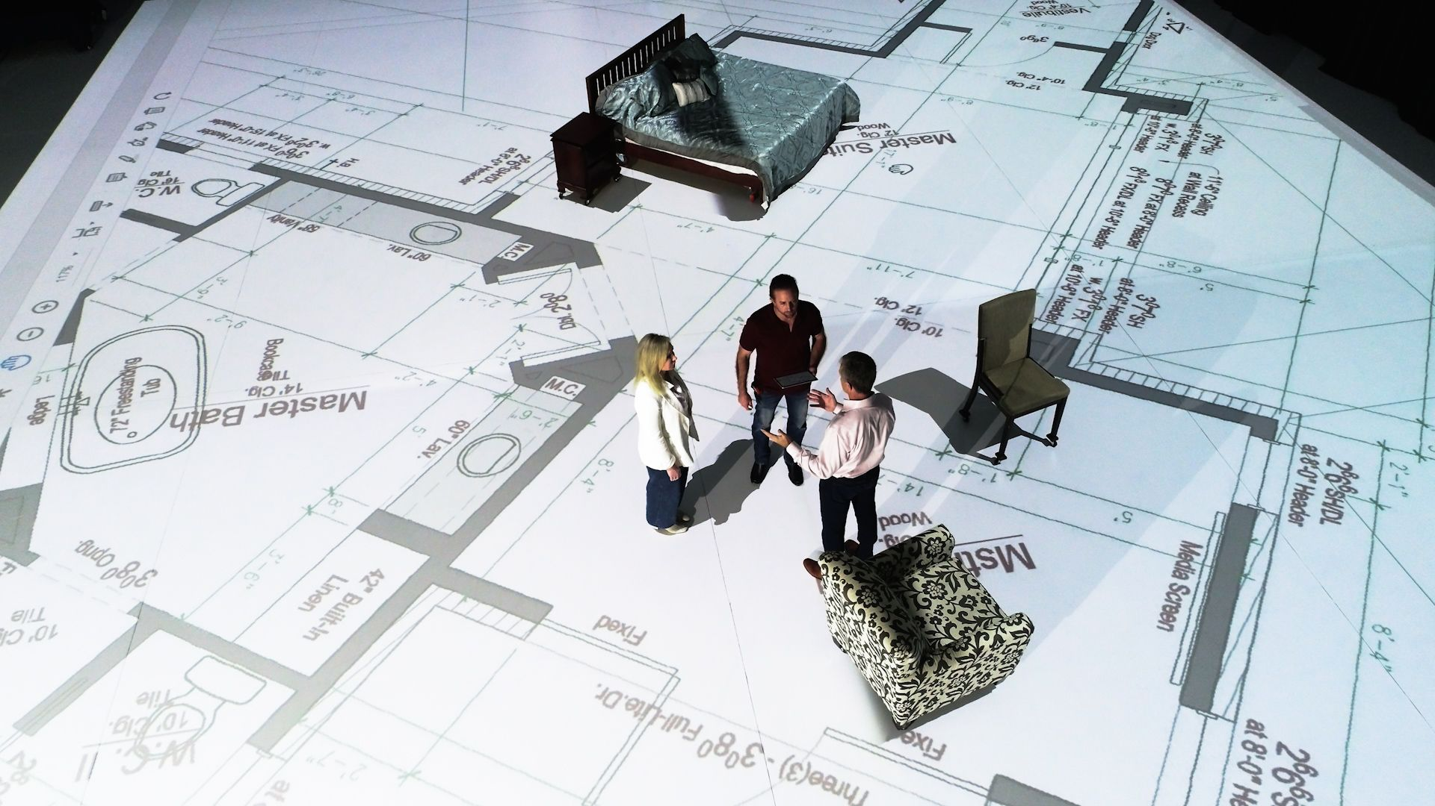
Credit: Real Photo, not photo shopped
"Previously, this technology was not available. I have over 15 years of expertise in the construction industry, and many times clients have expressed disappointment that plans that looked fine on paper were not what they wanted when it was complete. Our technology makes it very easy to see how a structure might look in every detail. Before construction begins, clients can walk through the 2D floor plan and make any adjustments they see fit. As a next step, clients can utilize our augmented reality or mixed reality services for a complete immersive experience. This technology has enormous promise in the construction industry, and we have had thousands of inquiries from around the world," says Jay R. Schimpf, the President of Authenticus Inc.
- ADVERTISEMENT -
There are many factors that contribute to the finished design elements of a house. Whether designing, remodeling, or purchasing a house, the selections visualizer ensures the design elements, color combinations, textures, and overall design are to the clients preferences. The selection visualizing technology developed by Authenticus allows them to determine what direction to go.
In addition to the 2D studio service, Authenticus provides 3D high-definition renderings, 3D modeling, Augmented Reality, and Mixed Reality services to allow clients to imagine how the designs on paper would appear in real life. The company intends to display its revolutionary technology and the app it has created during the upcoming NAHB International Builders Show, which will be held in Las Vegas from January 31 to February 2. The company's Augmented Reality App is available now on both Apple and Android App stores.
"Our technology will be tremendously valuable for individuals developing, designing, or building in the commercial or residential industry. Whether utilizing our 2D scaling technology to see if their furniture will fit into the design's designated space, confirming color selections with our visualizer or creating depth or detail of a final product within our AR App. Authenticus is a singular partner with an immersive visual solution. In addition, we have grand plans to franchise our technology for the benefit of architects, builders, developers, designers, and real estate organizations across the country, " Concluded Jay. R. Schimpf.
About Authenticus Inc
Authenticus Inc. uses innovative technology solutions to help homeowners, architects, builders, developers, designers and real estate agents in the project design and creation process to save time and money in the long run.The company specializes in immersive 2D and 3D visualizations, renderings, modeling, augmented reality, virtual reality and mixed reality experiences. With Authenticus clients can avoid a wrong step by authenticating the next one.
Media Contact:
Name: Katherine Kistler
Email: support@authenticusservices.com
SOURCE: Authenticus
View source version on accesswire.com:
https://www.accesswire.com/732160/Authenticus-Inc-Makes-Use-of-Digital-Transformation-Tools-to-Assist-Homeowners-and-Designers-in-Avoiding-Expensive-Mistakes

