Acoustiblok, Inc. Names Baltimore-based Pyle Fence Company Manufacturing Representative for Acoustifence in Maryland

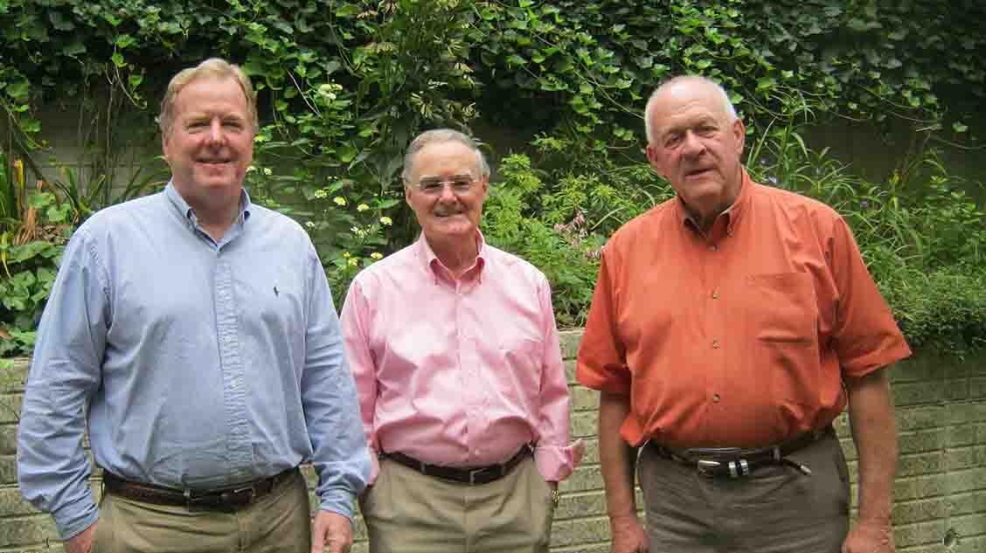

(Left to Right): Bill Pyle, Peter Bonnett, and John Brown will work together

to bring Acoustiblok sound abatement products to Maryland, Delaware, and

Washington, D.C.

TAMPA, Florida, September 12, 2012 – [Acoustiblok, Inc.](http://www.acoustiblok.com) Founder and President Lahnie Johnson this week approved a working agreement with Pyle Fence Company of Baltimore, Maryland as Acoustiblok’s manufacturing representative for Acoustifence noise reduction fencing material in the State of Maryland. Pyle Fence President Bill Pyle, working in conjunction with retired Engineer Peter Bonnett of Clarkesville, and John Brown of Frederick will represent Acoustifence and other Acoustiblok products throughout the State of Maryland, as well as in Delaware and Washington, DC.

Baltimore-based [Pyle Fence Company](http://pylefence.com/) has been owned and operated by the Pyle family since 1939, building all styles of fences for industrial, commercial, and residential installations.

Pyle, a resident of Lutherville, Maryland, has served as president of Pyle Fence since 1980. He earned a bachelor’s degree in Business Administration from St. Francis University in Loretto, Pennsylvania, and currently serves on the Education Foundation Board of the Better Business Bureau.

Peter Bonnet is a retired mechanical engineer with more than 45 years’ experience in Scientific Instrumentation, Analytical Sciences, and biotechnology-related fields. The UK native earned a Mechanical Engineering degree from the University of South Bank in London, and has focused a large portion of his career on corporate and divisional business development, sales, and marketing. Bonnet is a resident of Clarkesville, Maryland.

John Brown has more than 40 years’ experience in construction-related industries, most notably with Caterpillar Corporation in Frederick. Brown attended American University and studied veterinary medicine at the University of Maryland. During his career, Brown held a variety of management positions with a focus on technical sales and marketing. He is a resident of Frederick, Maryland.

“We’re very fortunate to have Pyle Fence Company representing Acoustiblok in Maryland, and we welcome all three of these knowledgeable gentlemen to our growing team,” Johnson says. “Our team continues to grow nationwide, and Mr. Pyle, Mr. Bonnett and Mr. Brown represent the high caliber associates Acoustiblok demands.”

**About Acoustifence:**

Acoustiblok, Inc., a [NASA spin-off](http://www.thermablok.com/thermal-insulation/themablok-named-nasa-spinoff-press-release.htm) company, has been providing high quality noise abatement products since 1998, earning the industry’s highest ratings from architects, builders, consumers, and even the British House of Commons. Acoustifence is a 1/8-inch (3mm) thick unique sound deadening material measuring 6 feet (1.82 meters) high by 30-feet (9.14 meters) long with black anodized brass eyelets along the top and bottom edge for easy attachment to any existing fence or structure.

Heavy-duty nylon ties are included with each roll. Easily installed or removed in less than one hour, impervious to mold, mildew, and UV, Acoustifence is virtually indestructible. The soundproofing material in Acoustifence is a proprietary formula of the Acoustiblok Corporation, developed and refined over a 10-year period.

Acoustifence has proven performance and is easily suspended from a chain link fence, eliminating the need for expensive permitting or structural requirements. Any height can be obtained by simply overlapping the sections. To store, Acoustifence sections simply roll up like carpet into less than a 12-inch diameter. Independent lab tests of the U.S.-made Acoustifence material show a sound transmission classification (STC) of 28, which represents to the human ear an approximately 85-percent sound reduction. However, results will be less, relative to surrounding sound reflective objects such as buildings or trees and the amount of Acoustifence installed.

Acoustiblok, Inc. also has available high quality landscape attachments which fit directly over the Acoustifence to provide a realistic landscape appearance. A variety of landscape attachments are available to choose from, including floral gardens, green meadows, English garden walls, and other scenic illustrations to blend into any natural backdrop or enhance an unfinished yard or property.

For more information on Acoustifence, visit the [Acoustiblok website](http://www.acoustiblok.com/), call 813-980-1400, or E-mail [sales@acoustiblok.com](mailto:sales@acoustiblok.com).

###

**PRESS RELEASE**

*For Immediate Release*   
Contact: Liz Ernst, Director of Public Relations  
[Lizernst@acoustiblok.com](mailto:Lizernst@acoustiblok.com)  
813.980.1400 x 210