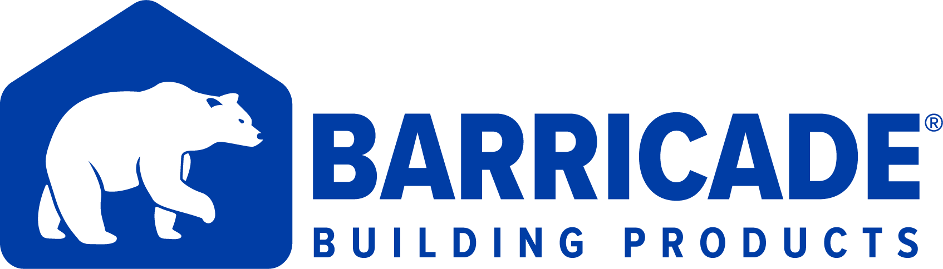

Barricade Building Products to Showcase Energy-Efficient Building Envelope Products at IBS 2022

At this year’s NAHB International Builders’ Show (IBS 2022), Barricade Building Products will demonstrate how its patented structural sheathing and drainage house wrap products help builders deliver energy efficient homes that consumers are demanding.

Richmond, Virginia, Jan 25, 2022 (GLOBE NEWSWIRE) -- Barricade Building Products will showcase Barricade Thermo-Brace Structural Insulated Board (SIB), Barricade Thermo-Brace Lightweight Sheathing, and Barricade Plus Drainage Wrap at IBS 2022 in Orlando, Florida from February 8-10. The event will host more than 90,000 attendees, making it the largest light construction trade show in the world.
Barricade Thermo-Brace Structural Insulated Board (SIB)
Barricade Thermo-Brace SIB, a 4-in-1 reversible structural insulated sheathing with Barricade Thermo-Brace Structural Sheathing with BASF Neopor® GPS insulative foam, offers an additional energy-efficient insulative barrier against external elements and a tight, simple, and secure install for builders. Thermo-Brace SIB was a finalist for the Most Innovative Building Material Award last year at IBSx 2021.
Thermo-Brace SIB’s outside weather-resistant barrier (WRB) layers prevent water, moisture vapor, and mold and eliminate the need for additional outside protection, allowing homeowners to enjoy energy savings with a high indoor air quality. Mike Fields, Barricade Vice President of Sales, explains, “U.S. Department of Energy confirms that insulated sheathing, like Thermo-Brace SIB, plays a key role in the success of building energy efficient homes.”
Barricade Thermo-Brace Lightweight Structural Sheathing
Barricade Thermo-Brace Lightweight Structural Sheathing reduces labor costs by allowing builders to create an air and weather-resistant barrier on both sides in one lightweight step for better performance.
Josh Elliott, Technical Director for Barricade Building Products, explains, “Thermo-Brace is the best alternative to OSB. Not only is it lighter weight than OSB, but it also has waterproof WRB barriers on both sides that allow you to install your structural sheathing, WRB and air barrier at the same time. It’s hard to beat a 100% American made product that saves you time on the install and provides multiple properties to achieve a more energy efficient home.”
Barricade Plus Drainage Wrap
Barricade Drainage Wrap, with an innovative patented drainage design, offers ease of installation while providing consumers with maximum air and moisture control. The Drainage Wrap’s breathable membrane allows moisture vapor to pass through without becoming trapped, while the innovative non-directional drainage pattern moves water away from the home’s exterior.
Geoff Baldwin, President of INDEVCO North America Building Products Division said, “We’re excited to be back in person at IBS 2022 this year. In addition to Structural Sheathing alternatives and Drainage Wrap, we’ll showcase our complete Barricade Building Envelope System designed to create energy efficient homes.”
Barricade Building Products manufactures a complete Building Envelope System with a 10-year system warranty in Doswell, Virginia, just north of Richmond. The system includes House Wrap, Structural Sheathing, Roof Underlayment, Construction Seam Tape, and Window & Door Flashing.
Barricade Building Products is a member of INDEVCO North America Building Products Division. Barricade® is an INDEVCO North America brand.
For more information, visit Barricade Building Products website or contact:
Mike Fields - VP of Sales
Barricade Building Products
804-334-1379
MFields@BarricadeBP.com

Michelle Barnett - Communications Specialist
INDEVCO North America
804-876-9170
Michelle.Barnett@INDEVCO-NA.com

