Murphy Door Inc. Launches Murphy Beds to Complement Their Bookcase Hidden Doors
Murphy Door Inc. The Leading Manufacturer in Production Hidden Door Systems since 2005, has expanded their Hidden Solutions launching Murphy Beds. Beautifully crafted in Beadboard, Craftsman, Shaker, and Slab Styles they perfectly complement their Bookcase Hidden Doors.

By: Murphy Door Inc.
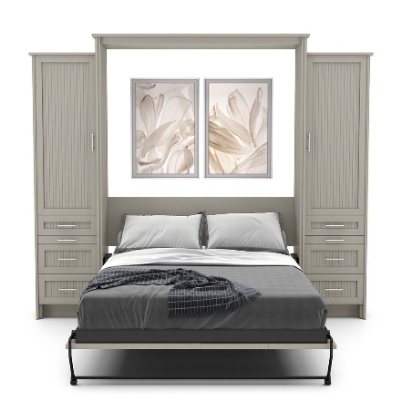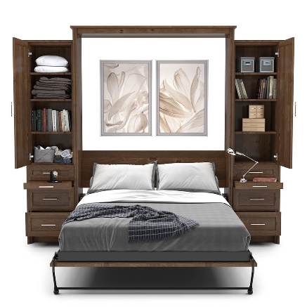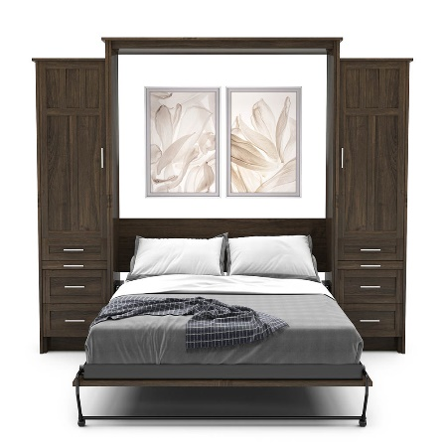

OGDEN, Utah – January 2022 -- Murphy Door Inc., the leader in hidden door systems, announced the addition of Murphy Beds to their product offering. A Murphy Bed, tucked neatly out of way until needed, adds to the functionality of any home. These smartly designed furniture-quality cabinets have a relatively small footprint, and a slight pull drops the bed into place. Compatible with coil mattresses up to 11” deep, they are the perfect sleep solution for maximizing studio living space and multi-purposing guest rooms. Beautifully crafted in Beadboard, Craftsman, Shaker, and Slab styles; King, Queen, and Twin sizes are available in 6 woods, 36 finishes, and the latest paint grade options that perfectly complement their bookcase hidden doors. Murphy Door Flush Mount Doors and Murphy Beds are proudly made in the USA at their manufacturing facilities in Utah and Kentucky.

Murphy Door has been featured in the HGTV Smart Home 2021, as well as on Fox & Friends with Skip Bedell, DIY, and This Old House, https://murphydoor.com/pages/featured-on. Murphy Doors have quickly become the must have in new homes and remodels and their Murphy Beds will surely follow suit. These on demand beds are beautifying homes while adding functionality to the smallest of spaces. Whether you need to maximize studio living space or have a guest room that will double as an office or work out area, Murphy Door Inc. has an answer. See more at https://murphydoor.com/pages/gallery-2021.
Jeremy G. Barker, Murphy Door Inc. CEO states, "Murphy Beds are the next step in the “Maximize Your Space” puzzle. We have brought our patented hinge system expertise and quality craftsmanship to our new Murphy Bed line. Our spring-loaded mechanism ensures effortless opening and closing, and we have paired it with a steel bed frame that easily supports up to 1,000 lbs. Were confident that it will make a welcome addition to many homes.”
Murphy Door is actively seeking retailers, wholesalers, contractors, cabinet makers, and closet system companies around the world to carry their product line and help them fulfill these high demand products. Please visit their website at https://murphydoor.com for more information.

Email | : | marketing@murphydoor.com
Phone | : | 888.458.5911
Tags | : | Murphy Door, Hidden Door, Bookcase Door, Secret Passage, Hidden Door Hardware,  Panic Room, Murphy Bed
Industry | : | Furniture, Home, Hardware
Location | : | Ogden - Utah - United States
Subject | : | Products

