Murphy Door Inc. Adds Functionality and Storage to Any Doorway with Their Hidden Door Line
Murphy Door Inc. The Leading Manufacturer in Production Hidden Door Systems since 2005, has expanded their Flush Mount Hidden Door Line. Dresser, Gun Cabinet, Hamper, Mirror Closet, Pantry, Pool Cue, Spice Rack, and Wine Rack Doors add functionality and storage to any doorway.

By: Murphy Door Inc.
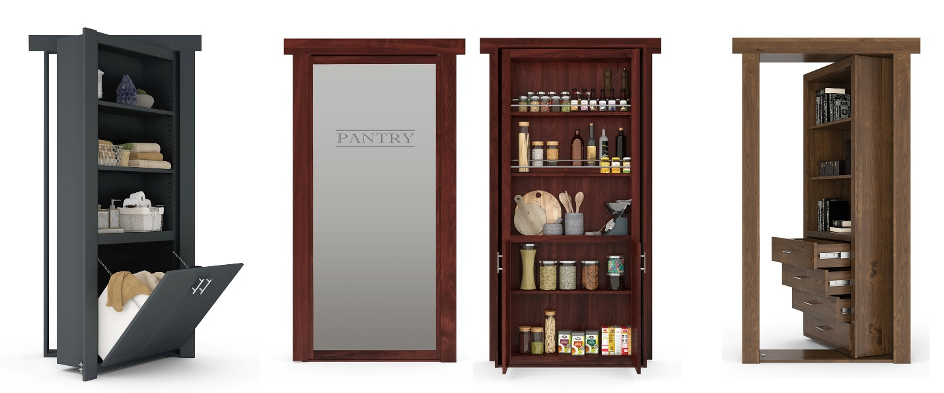

OGDEN, Utah – January 2022 -- Murphy Door Inc., the leader in hidden door systems has expanded their flush mount hidden door line. These smartly designed, furniture-quality doors easily conceal a room or space behind while adding 10 to 20 cubic ft of functionality and storage to previously wasted doorway space. Options include Bookcase, Dresser, Gun Cabinet, Hamper, Mirror Closet, Pantry, Pool Cue, Shoe Rack, Spice Rack, and Wine Rack Doors. Standard, Custom, and French Door sizes are available in 6 woods, 36 finishes, and the latest paint grade options. Murphy Door Flush Mount Hidden Doors and Murphy Beds are proudly made in the USA at their manufacturing facilities in Utah and Kentucky.

Murphy Door has been featured in the HGTV Smart Home 2021, as well as on Fox & Friends with Skip Bedell, DIY, and This Old House, https://murphydoor.com/pages/featured-on. Murphy Doors have quickly become the “Must Have” item in new homes and remodels. These hidden door/secret passage systems are beautifying homes and adding functionality to every room in the home. Their door systems have been used for everything from functional pantry doors seamlessly adding storage to a kitchen, to closet doors with hampers or drawers that replace the unused door space. Murphy Beds are another piece in the “Maximize Your Space” puzzle that will not only wow the neighbors but become a highly used piece within your home. Whether you have a room you wish to keep concealed, a discerning buyer that require the safety of a panic room, or lack the space to dedicate to a seldom used guest room; Murphy Door Inc. has an answer. See more at https://murphydoor.com/pages/gallery-2021.
Jeremy G. Barker, Murphy Door Inc. CEO states, "The Murphy Door patented hinge system has lower thrust bearings as well as bearings in each of the pivoting components enabling the load of the door to carry 300 lbs. while functioning with ease. In addition, the pivot points are spring loaded. Competitors' hinges pivot on the threads of a bolt which over time will fail causing play in the hinge. Murphy Door hinges pivot on a smooth shaft which will serve a lifetime of trouble-free use. We continue this tradition bringing high-quality craftsmanship, ease of function, and innovative technology to our Murphy Bed line.”
Murphy Door is actively seeking retailers, wholesalers, contractors, cabinet makers, and closet system companies around the world to carry their product line and help them fulfill these high demand products. Please visit their website at https://murphydoor.com for more information.

Email | : | marketing@murphydoor.com
Phone | : | 888.458.5911
Tags | : | Murphy Door, Hidden Door, Bookcase Door, Secret Passage,  Hidden Door Hardware, Panic Room, Murphy Bed
Industry | : | Furniture, Home, Hardware
Location | : | Ogden - Utah - United States
Subject | : | Products

